1. **Understanding the problem**

My goal is to allow the player to set the maximum and minimum speed limit(100~500km/h) of ten contestants and the length of the race course(10~200km) in the car race. Then the program prints out randomly the speed of each contestants and the time when each contestant ends the race. After that, the program prints out the winner of the race.

**Assumption**

I assume that negative number input will not be counted as settings of the race.

I assume that decimal number input will no be counted as settings of the race.

I assume that if the player enter invalid numbers, the program will ask player to enter valid numbers again.

**Name of racers**

1. Tachyon
2. Higgs
3. Flash
4. Silver Suffer
5. Berry Alan
6. Lightning Mcqueen
7. AeroSmith
8. Speedster
9. Velocirapter
10. Godspeed
11. **Devising a Plan**

**Flow Chart**

**<int main()>**

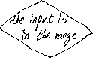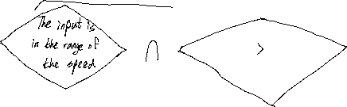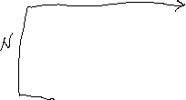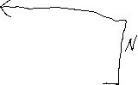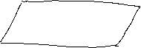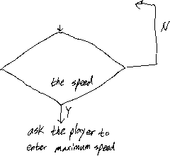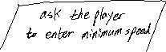

**<float speed_time(racer[ ], int n, int L)>**

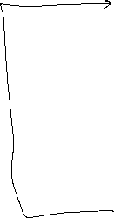

**<int winner(racer[ ],int n)>**

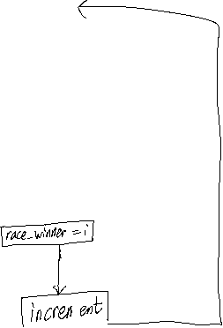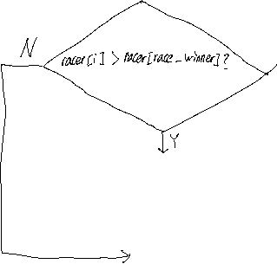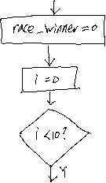

**Strategy**

I predict that it will take about three hours to implement this program. First of all, I will make the function that prints out the speed of each racer randomly and calculate the time when each racer finishes the race. Moreover, I will make the function that prints out the winner of the racer. It means that this function finds out which racer’s speed is the fastest. If these functions are working, in the ‘int main()’, I will set the conditions that check whether the player’s input is valid or not and by allowing the player to enter the numbers correctly, I will make the program print out the speed of each racer and the time when each racer finishes the race, and print out the winner of the race.

1. **Test cases**

|  |  |  |
| --- | --- | --- |
| **Setting** | **Input** | **Expected Result** |
| What is the minimum car speed in km/h (100~500)? | -1 | Please try again; enter a number between 100 and 500: |
| What is the minimum car speed in km/h (100~500)? | 150 | What is the maximum car speed in km/h (100~500)? |
| What is the minimum car speed in km/h (100~500)? | 600 | Please try again; enter a number between 100 and 500: |
| What is the maximum car speed in km/h (100~500)? | 200  (because the minimum car speed is 150km/h) | How long is the race course in km (10~200)? |
| What is the maximum car speed in km/h (100~500)? | 100  (because the minimum car speed is 150km/h) | Please try again; enter a number between 100 and 500: |
| What is the maximum car speed in km/h (100~500)? | 1000 | Please try again; enter a number between 100 and 500: |
| How long is the race course in km (10~200)? | 300 | Please try again; enter a number between 10 and 200: |
| How long is the race course in km (10~200)? | 0 | Please try again; enter a number between 10 and 200: |